SETTING UP ENVIRONMENT CREATE FLASK PROJECT

|  |  |
| --- | --- |
| Team ID | PNT2022TMID17805 |
| Project Name | Customer Care Repositry |
| Team Members | Abishek L, Athista Laskhmi,  Balamurugan G, Harshini |

**Step 1:** Beginning the Flask installation with python installation from the official account: <https://www.python.org/>.

Run the python setup and install the newest version of python.

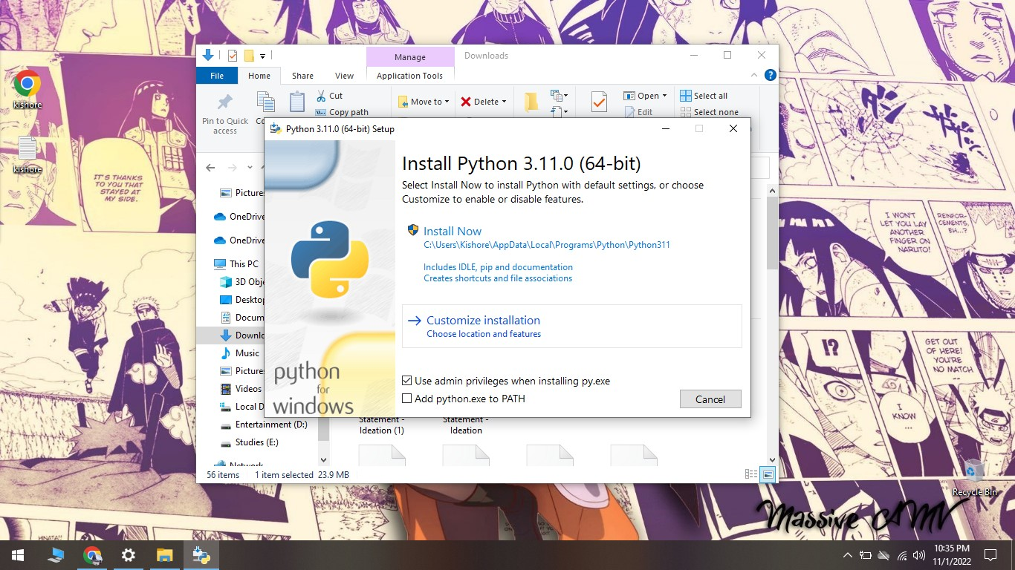

**Step 2:** Open Command Prompt and cross-verify the installation of python by typing: To check the version : **python --version**

To check the path :**pip --version**

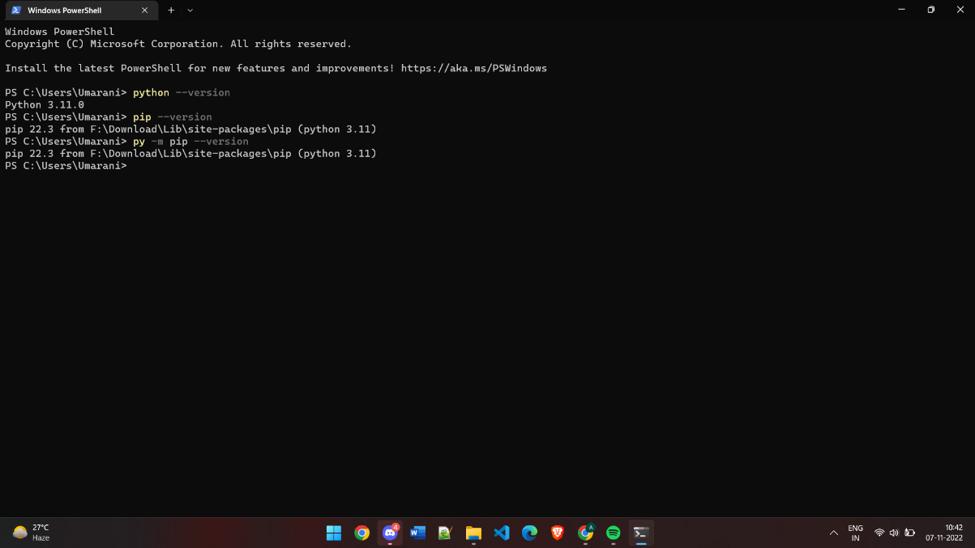

**Step 3:** After python installation, we need to begin with flask installation by typing : Flask installation : **py -m install flask**

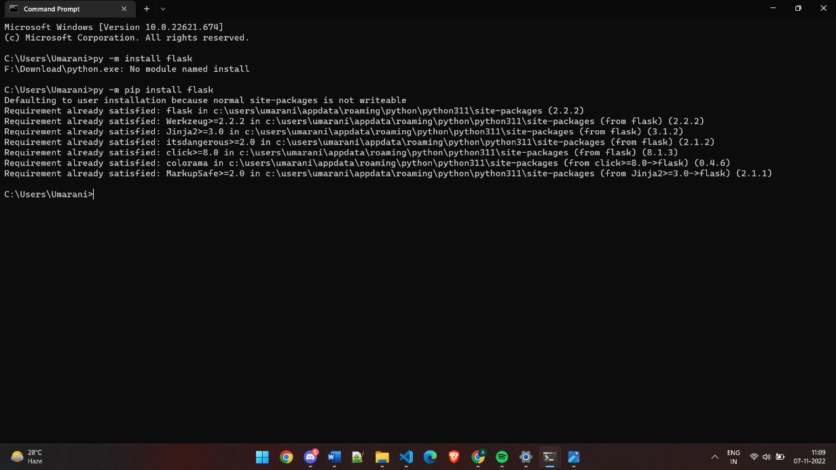

**Step 4:** Now the new version of Python-Flask is successfully installed

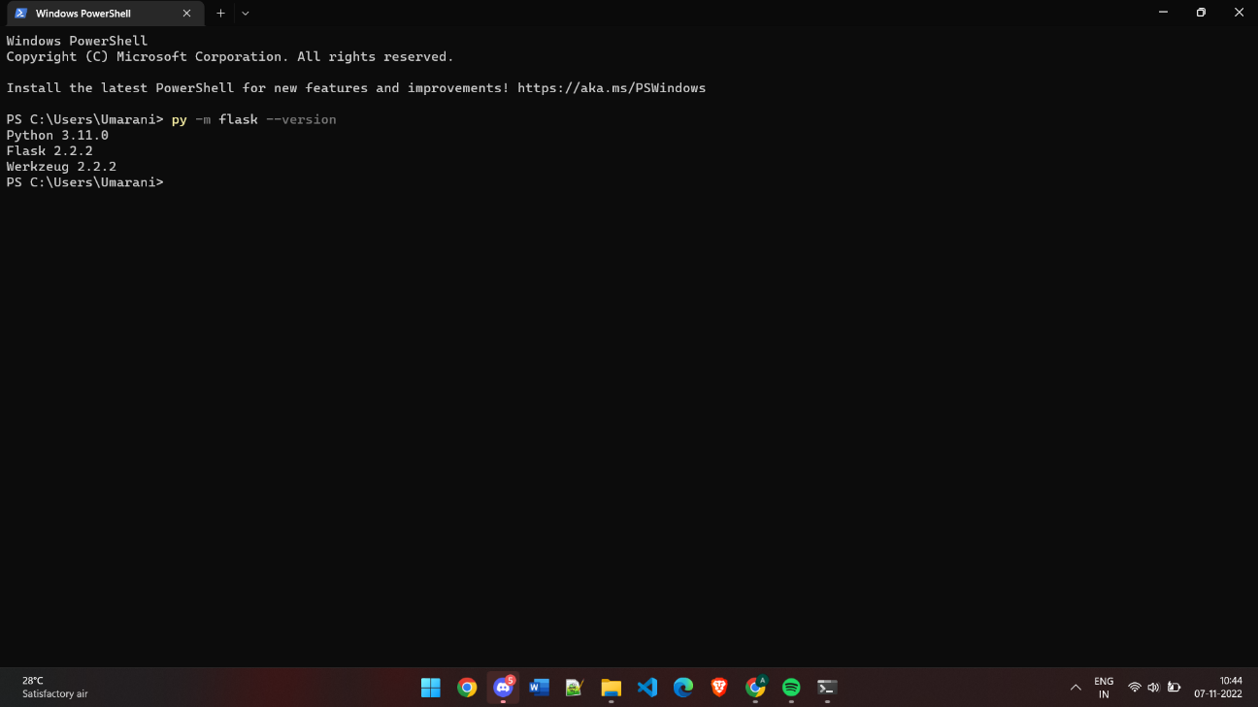

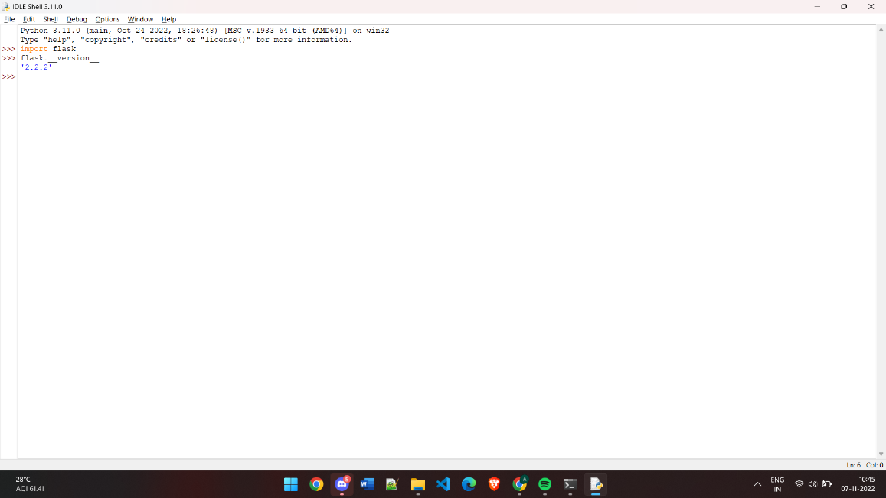

**Step 5:** Now to run a simple project open VS Code and type the following:

**from flask import Flask app = Flask( name ) @app.route("/") def hello_world():**

**return "<p>Hello, World!</p>"**

And save the file as “app.py” copy its path and run it in the command prompt along with syntax **flask run**

